Assignment -4

SMS SPAM Classification

|  |  |
| --- | --- |
| Assignment Date | 08 October 2022 |
| Student Name | Narmadha T |
| Student Roll Number | 612919103066 |

* Download the Dataset: - [Dataset](https://www.kaggle.com/code/kredy10/simple-lstm-for-text-classification/data)
* Import the necessary libraries

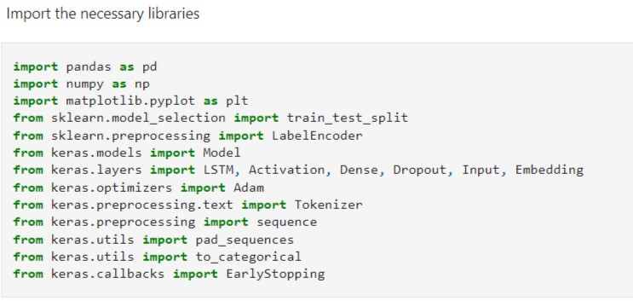

* Read dataset and do pre-processing

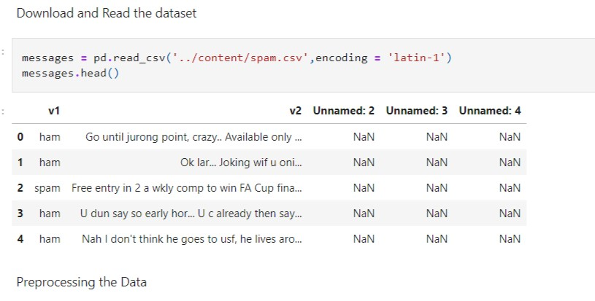

* Pre-processing the dataset

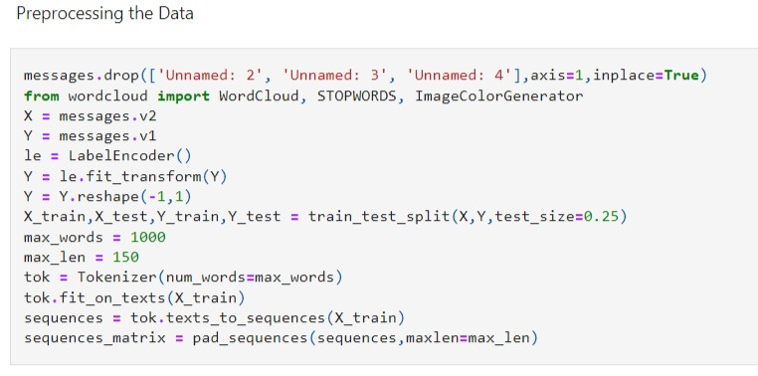

* Create Model

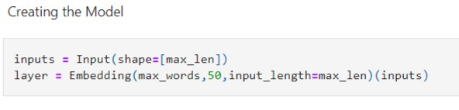

* Add Layers (LSTM, Dense-(Hidden Layers), Output)

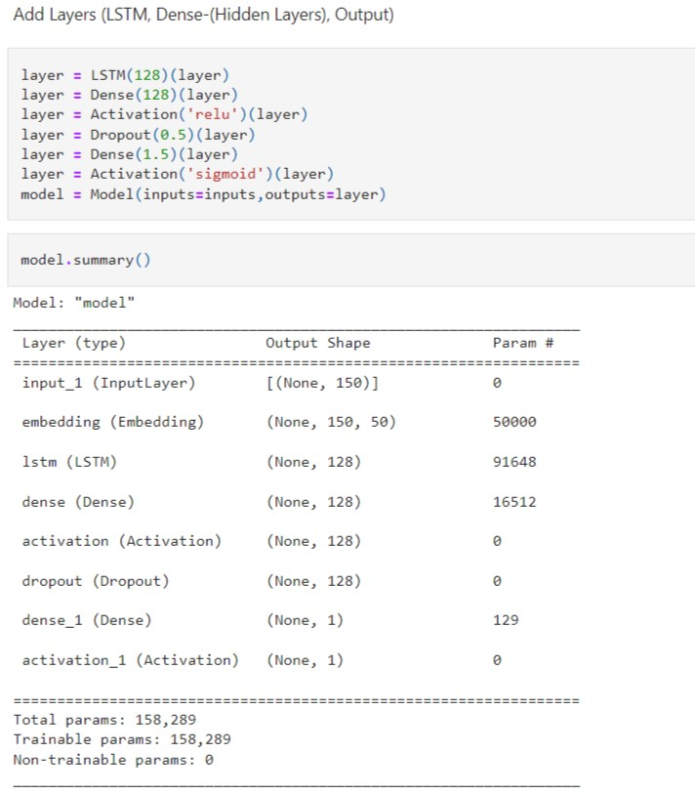

* Compile the Model

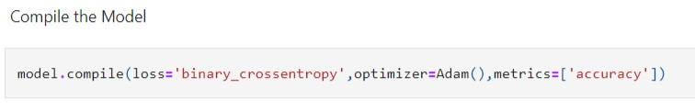

* Fit the Model

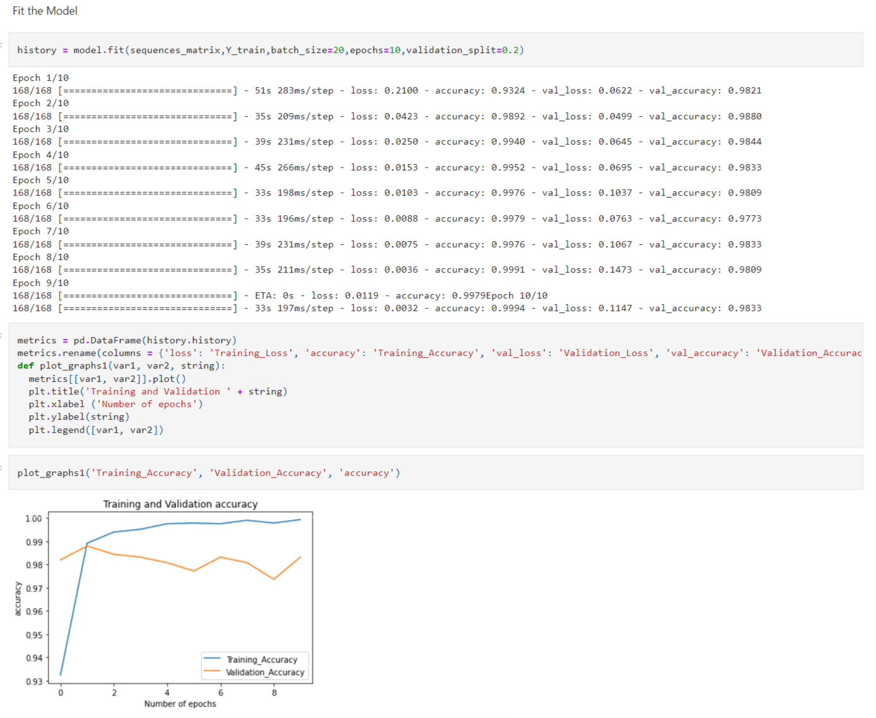

* Save The Model

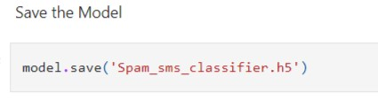

* Test The Model

